**Project Title**

**1. Introduction**

**Give a brief introduction to your project and the list of features. Summarize in a few sentences what you proposed in the ideation report.**

I plan on designing an ecommerce website for a dessert shop. My focus is on creating a user-friendly design with a lot of visual functionalities. Some of the functionalities I plan on using are carousel, accordion, popovers, tooltips, responsive features for different devices, to name a few.

**2. User Interface Design and Prototype**

**Give some sample user interface layouts for your application. You can use either wireframe diagrams or prototyping tools to construct the mock representations of your UI design. Briefly explain the rationale behind designing your UI and how it is geared towards supporting the list of features for your application.**

Please find attached interface layouts. I have explained the reason for the features in the pictures.

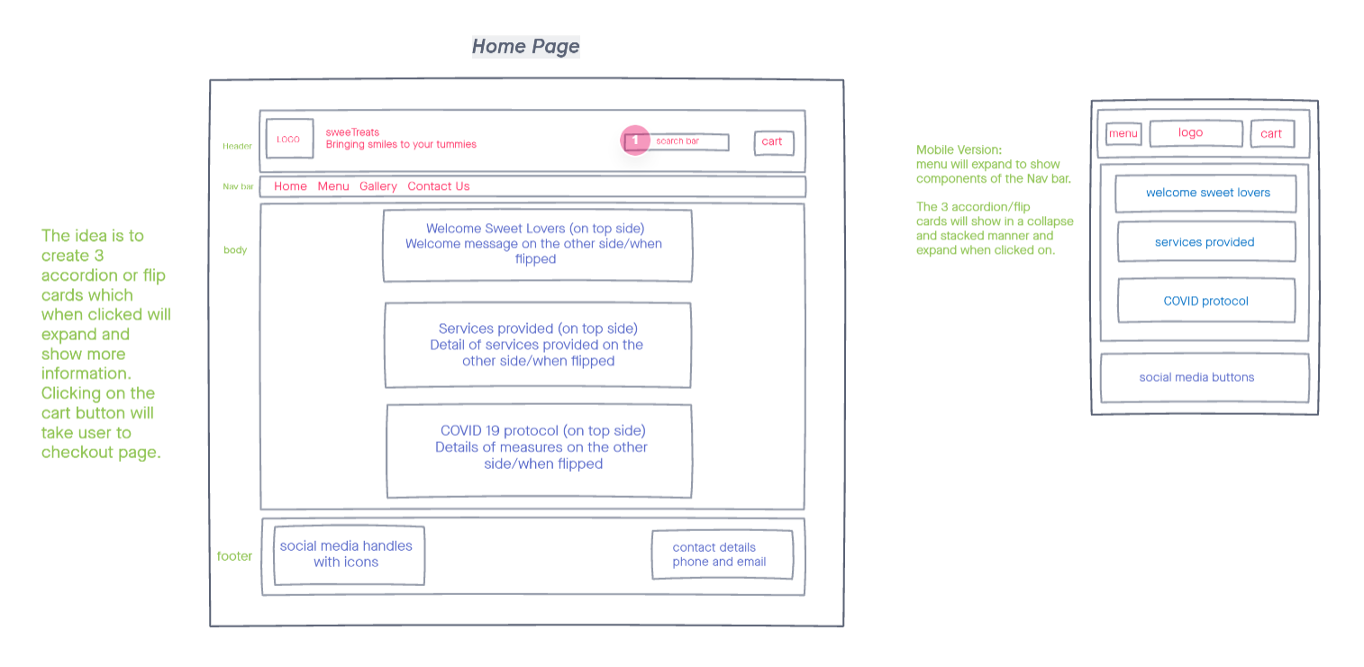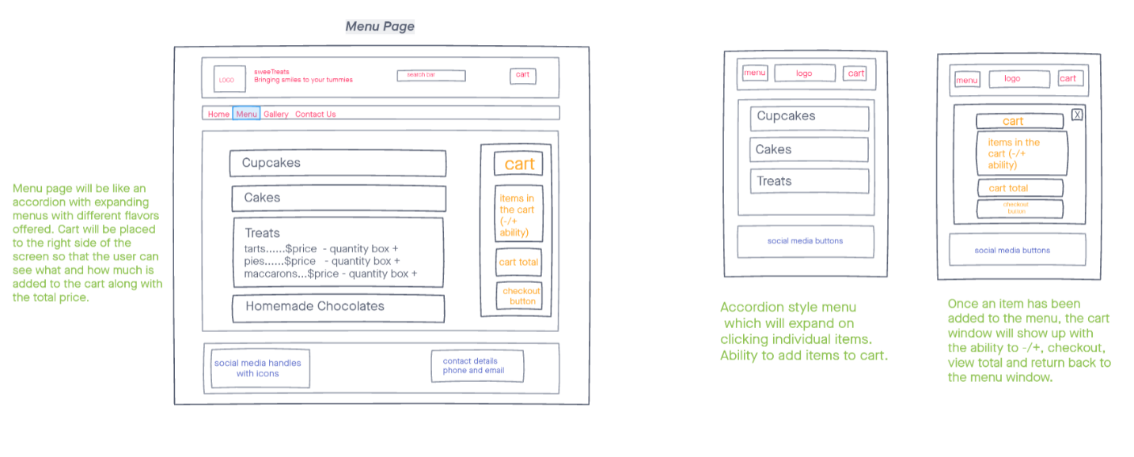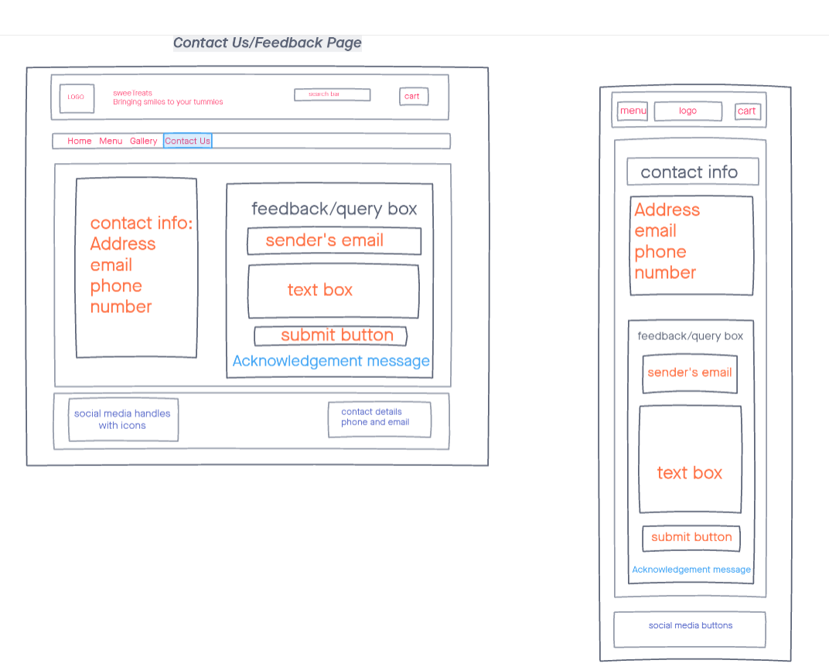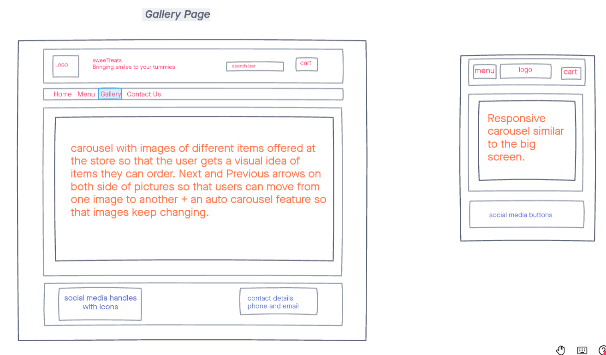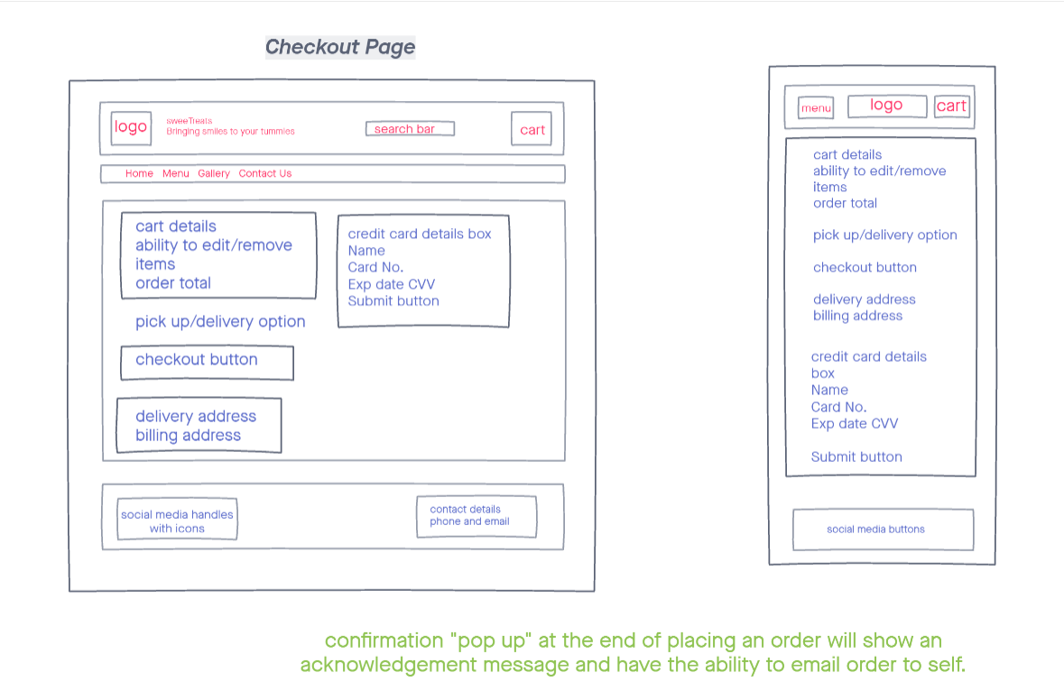

**3. Navigation Structure**

**Give a brief overview of the navigation structure for your application.**

**Briefly indicate a typical flow of your application in terms of user experience. You can use any way of representing the flow. You can also construct a prototype using one of the prototyping tools to illustrate this.**

The normal flow of the site will be:

home page🡪menu🡪add items to cart🡪checkout🡪confirmation of order.

Additional features will be gallery and contact us page with the ability to provide feedback or to ask questions to the seller.

Please find below the plan for the navigation system of the website.

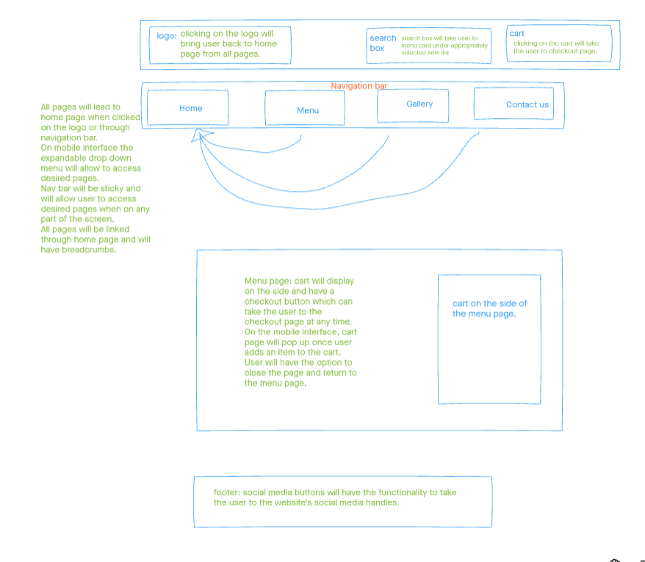

**4. References**

**Provide any references relevant to the report.**

<https://www.youtube.com/watch?v=KdfO_e0yK-g>

<https://www.youtube.com/watch?v=2hQA1ZsGAH8>

<https://www.bigcommerce.com/blog/food-beverage-ecommerce-design/#best-food-beverage-ecommerce-brands>

<https://www.scnsoft.com/ecommerce/selling-food-online>

<https://www.youtube.com/watch?v=dgKSqz3it50>

<https://rustikacafe.shop/>

<https://sweettreatsdesahana.wixsite.com/kidbaker/menu>

<https://order.thanx.com/kolachefactory>

<https://www.sugarfootsdelivery.com/online-ordering>

<https://thecakeshopsat.com/>

<https://www.smallcakescupcakery.com/flavors/>

<https://www.truefoodkitchen.com/menu/>

<https://www.practicalecommerce.com/Build-a-Responsive-Mobile-first-Cart-Page-with-Bootstrap>

<https://www.youtube.com/watch?v=1H7Ql9hmbuM>